Thermodynamic Liquid Manifold Networks: Physics-Bounded Deep Learning for Solar Forecasting in Autonomous Off-Grid Microgrids
Mohammed Ezzaldin Babiker Abdullah
Department of Electrical and Electronic Engineering, Faculty of Engineering Sciences
Omdurman Islamic University, Omdurman, Sudan
Izzeldeenm@gmail.com

Abstract
The stable and uninterrupted operation of autonomous off-grid photovoltaic energy systems dictates an absolute reliance on solar forecasting algorithms that inherently respect the fundamental laws of atmospheric thermodynamics. Despite the widespread implementation of advanced deep learning architectures, contemporary predictive frameworks consistently exhibit critical thermodynamic anomalies. These structural deficiencies manifest primarily as severe temporal phase lags during transient cloud events and physically impossible artificial power generation during nocturnal periods, both of which severely compromise the operational safety of isolated microgrid dispatch controllers. To permanently resolve the critical divergence between purely data-driven sequence modeling and deterministic celestial mechanics, this research introduces the Thermodynamic Liquid Manifold Network, a novel predictive topology engineered for absolute physical compliance. Instead of relying on conventional recurrent sequences or standard attention mechanisms, the proposed methodology projects 22 precisely selected variables encompassing meteorological, geometric, dynamic derivatives, and cumulative physical memory into a Koopman-linearized Riemannian manifold. Within this stabilized geometric space, complex non-linear climatic dynamics are systematically mapped and spectrally filtered. The architecture integrates a specialized Spectral Calibration unit functioning in tandem with a multiplicative Thermodynamic Alpha-Gate. Acting as a strict thermodynamic governor, this gating system dynamically synthesizes real-time localized atmospheric opacity with theoretical Ineichen-Perez clear-sky boundary models. This operation structurally enforces strict celestial geometry compliance, absolutely neutralizing phantom nocturnal generation while maintaining zero-lag synchronization during rapid weather shifts. Validated against a rigorous five-year independent testing horizon characterized by severe optical degradation and Harmattan dust intrusions in a semi-arid climate, the introduced manifold framework achieves exceptional accuracy. The empirical performance demonstrates a Root Mean Square Error of 18.31 Wh/m² and a Pearson correlation coefficient of 0.988. Furthermore, the model strictly maintains a zero-magnitude nocturnal error across all 1826 testing days and exhibits a sub-30-minute phase response during high-frequency optical transients. Comprising exactly 63,458 trainable parameters, this ultra-lightweight architectural design establishes a fundamentally robust and thermodynamically consistent standard for edge-deployable microgrid controllers.
Keywords: Thermodynamic Liquid Manifold, Koopman Operator, Riemannian Geometry, Spectral Calibration, Alpha-Gate Governing, Solar Irradiance Forecasting, Edge Computing

1. Introduction
The precise forecasting of surface-level solar irradiance represents a profoundly complex predictive challenge governed by a strict thermodynamic and optical duality. The primary component of this system is dictated by deterministic celestial geometry, which establishes the absolute theoretical upper boundary of incoming shortwave radiation based on planetary orbital mechanics and astronomical positioning (Gueymard, 2004; Ineichen & Perez, 2002). Conversely, the secondary component is dominated by the highly stochastic optical attenuation driven by turbulent atmospheric boundary layer dynamics. In severe semi-arid environments, this duality reaches its operational extreme. The region simultaneously experiences exceptionally high clear-sky solar potential and violent meteorological volatility, including sudden cumulus cloud formations and massive Saharan dust intrusions that drastically alter atmospheric transmissivity in a matter of minutes (Kosmopoulos et al., 2017; Polo et al., 2020). Consequently, effective predictive modeling for autonomous off-grid microgrids cannot rely solely on empirical clear-sky equations or pure statistical pattern recognition, but requires an integrated framework capable of mapping extreme atmospheric stochasticity while strictly adhering to the deterministic energy envelopes imposed by astrophysics (Inman et al., 2013; Stackhouse et al., 2023).
Despite the widespread integration of advanced deep learning methodologies in renewable energy forecasting, contemporary sequence architectures fundamentally struggle to maintain these essential thermodynamic boundaries (Mellit & Kalogirou, 2008; Voyant et al., 2017). Traditional recurrent neural networks and their gated variants process atmospheric transitions through sequential latent state averaging. This specific architectural mechanism inevitably induces severe temporal phase distortions and lag artifacts during rapid optical shifts, such as sudden cloud clearances or the immediate onset of dust storms, thereby delaying critical control signals for battery dispatch systems (Hochreiter & Schmidhuber, 1997; Kumar et al., 2021). To mitigate sequential bottlenecks, the field has increasingly adopted global self-attention mechanisms and Transformer-based architectures (Vaswani et al., 2017; Wen et al., 2022). However, these models operate entirely within an unconstrained mathematical feature space. Devoid of an absolute physical reference frame, attention-driven models frequently violate fundamental energy conservation principles. The most critical manifestation of this structural flaw is the synthesis of mathematically positive irradiance values during nocturnal zero-energy periods, creating a phantom generation profile that severely corrupts the operational logic of isolated energy management systems (Zang et al., 2020; Zhao et al., 2025).
While recent advancements in physics-informed neural networks attempt to rectify these violations by embedding mathematical penalty terms within the optimization loss function, this paradigm provides only soft statistical compliance. Penalty-based constraints merely guide the gradient descent during training but structurally fail to guarantee absolute physical compliance during real-time edge inference, particularly when the network encounters novel atmospheric extremes not fully represented in the training distribution (Karniadakis et al., 2021; Raissi et al., 2019). To definitively resolve the critical divergence between empirical data-driven sequence modeling and the absolute limits of celestial mechanics, this research advocates for a fundamental architectural shift toward topological manifold mapping and structural thermodynamic governing. By engineering an architecture where the physical energy envelope operates as a hard computational boundary rather than a statistical penalty, it becomes mathematically possible to strictly enforce the fundamental laws of energy conservation by design.
In response to these critical operational requirements, this research introduces the Thermodynamic Liquid Manifold Network (TLMN v3), presenting four core architectural innovations engineered to permanently eliminate the structural and thermodynamic flaws of contemporary deep learning models:
First: The implementation of a Koopman-Linearized Riemannian Manifold. This geometric operation dynamically transforms the 22-dimensional input matrix into a stabilized topological continuum. This unrolling enables the precise spectral isolation of the underlying diurnal orbital frequency from high-frequency turbulent aerosol noise, entirely circumventing the limitations of standard flat sequence processing.
Second: The deployment of a Multi-Resolution Dilated Convolutional Encoder. This component processes the constructed manifold across logarithmically expanding receptive fields. Operating exclusively via feedforward spatial mapping, this encoder captures the complete spectrum of climatic transients from sub-hourly optical shifts to complete diurnal patterns without the internal state accumulation mechanisms that historically trigger temporal phase lag.
Third: The introduction of a specialized Spectral Calibration unit. The architecture abandons traditional data-driven attention modules to mathematically isolate meteorological features from celestial geometries. This mechanism forces the learned statistical representations to be continuously calibrated against theoretical clear-sky limits, structurally preventing data-driven features from overriding astronomical energy boundaries.
Fourth: The integration of a Multiplicative Thermodynamic Alpha-Gate. This terminal gating system establishes an absolute mathematical boundary for the forecasting process. It synthesizes a localized atmospheric transmissivity scalar that strictly bounds the final prediction, structurally guaranteeing exact zero-magnitude propagation during all nocturnal hours and definitively neutralizing the possibility of physical limit violations regardless of internal network weights.

2. Methodology
This section delineates the core architectural design and theoretical formulations of the Thermodynamic Liquid Manifold Network (TLMN v3). Engineered specifically to overcome the structural deficiencies of unconstrained sequence modeling, the proposed methodology is systematically organized into four interconnected phases. First, the data architecture and boundary conditions are defined to establish an absolute astrophysical anchoring. Second, the 22-dimensional input trajectory is unrolled into a Koopman-Linearized Riemannian Manifold, functionally decoupling stable orbital mechanics from highly stochastic boundary-layer turbulence. Third, a multi-resolution spatial encoder extracts phase-aligned spectral features without relying on latency-inducing recurrent memory states. Finally, the inference culminates at the Thermodynamic Alpha-Gate, where data-driven meteorological representations are multiplicatively governed by deterministic celestial limits to guarantee absolute physical compliance.

2.1 Data Architecture
The analytical framework was developed utilizing high-fidelity meteorological records for Omdurman, Sudan, representing a severe semi-arid climatic profile characterized by extreme optical volatility. The geographical coordinates dictate an environment subject to intense Harmattan dust transports and rapid inter-tropical convective formations, establishing a highly challenging baseline for atmospheric predictability.The input matrix is strictly composed of 22 variables (summarized in Table 1), encompassing direct, diffuse, and global radiation components, local ambient thermodynamic conditions alongside their first-order dynamic derivatives, cumulative optical memory, deterministic celestial parameters, and continuous cyclical temporal embeddings, local ambient thermodynamic conditions, and deterministic celestial parameters sourced from the NASA POWER global reanalysis product.
To ensure absolute prevention of temporal data leakage and to rigorously assess multi-year thermal stability under optical degradation, the temporal timeline was partitioned into strictly isolated blocks. The primary developmental phase encompasses the period from 2010 to 2015, establishing the foundation for network training and architectural validation.
A completely independent evaluation phase, spanning exactly 1826 days from 2020 to 2024, was reserved exclusively for continuous temporal stress-testing. This multi-year temporal buffer ensures that the predictive manifold is evaluated on entirely unseen climate epochs, validating the true multi-year generalization capability of the architecture against shifting atmospheric statistics.
Table 1. Input Feature Matrix of TLMN v3: Physical Categorization and Computational Roles.
Category | Symbols | Role
Solar Target | $$GHI$$ | Regression output
Physics Anchor | $$GHI_{clear}$$ | Thermodynamic gate multiplicand
Spectral Inputs | $$K_{t},SZA$$ | Spectral calibration input
Base Meteorological | $$DNI,DHI,T_{2m},RH,WS,P_{s}$$ | Spectral calibration input
Dynamic Derivatives | $$ΔT_{2m},ΔRH,ΔWS,ΔP_{s}$$ | Topological state space feature
Cumulative Memory | $$\overline{DNI},\overline{DHI}$$ | Topological state space feature
Composite Index | $$TSI$$ | Topological state space feature
Temporal Cycles | $$\sin\left(M\right),\cos\left(M\right),\sin\left(D\right),\cos\left(D\right),\sin\left(H\right),\cos\left(H\right)$$ | Continuous temporal embedding

To enforce structural thermodynamic limits within the predictive framework, the architecture derives explicit physical anchors directly from chronological and geographical metadata. The deterministic celestial geometry is mathematically defined by extracting the real-time solar zenith angle. Rather than relying on standard sequential trigonometric formulations, this geometric projection is treated as a continuous orbital vector defined by the local latitude and the dynamically evolving solar declination. This calculation provides an absolute, astronomically governed reference frame for the internal predictive topology. Concurrently, the theoretical upper boundary of atmospheric transmittance is established utilizing the Ineichen-Perez clear-sky model. This theoretical baseline facilitates the extraction of the local clearness index, functioning as a dimensionless scalar that captures the real-time optical attenuation of the turbulent boundary layer prior to neural processing. Furthermore, to prevent the network from encountering the severe numerical discontinuities inherently associated with discrete ordinal time representations, all temporal indices are transformed into a continuous geometric space. By mathematically projecting the chronological timestamps onto a bi-dimensional unit circle via continuous trigonometric functions, the temporal variables are encoded as seamless cyclical trajectories. This advanced
geometric encoding ensures that transitions between distinct days or months are processed by the network as smooth rotational translations. This continuous temporal manifold allows the downstream convolutional layers to accurately capture diurnal and seasonal periodicities without suffering from artificial logic breaks or boundary disruptions at the stroke of midnight.

2.2 Topological State Space
Addressing the fundamental limitations of standard flat sequence processing, the architecture dynamically unrolls the 15-dimensional atmospheric input trajectory into a multidimensional Riemannian manifold. This transformation is mathematically grounded in Koopman Operator Theory, which facilitates the projection of non-linear temporal dynamics into a higher-dimensional geometric space where the underlying atmospheric states operate in a linearized continuum. Instead of processing simple chronological vectors, the system constructs a sliding topological cuboid that preserves temporal causality along its anti-diagonal planes. This geometric expansion, visually conceptualized in Fig. 1, allows the predictive framework to fundamentally decouple the low-frequency deterministic orbital cycles from the high-frequency stochastic perturbations caused by moving aerosol masses and cloud transients. By elevating the raw data into this stable topological state space, the architecture completely circumvents the necessity for standard recurrent sequence formulations while providing a mathematically robust foundation for the subsequent spectral extraction layers.
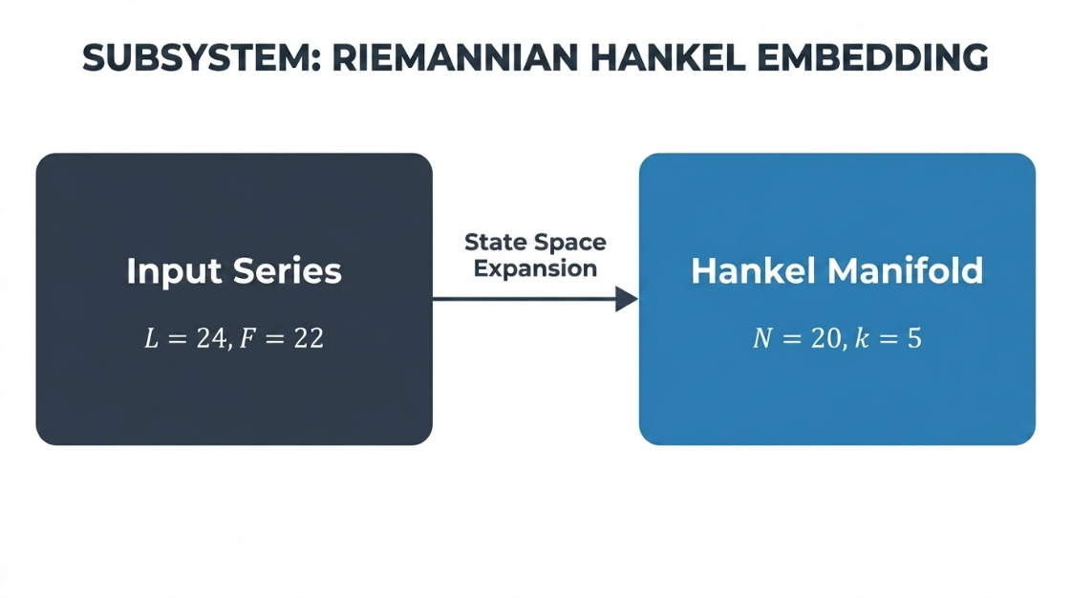
Fig. 1. Koopman-Linearized Riemannian Manifold Embedding for Topological State Space Expansion.

2.3 Spectral Feature Extraction
The constructed topological manifold is subsequently processed through a multi-resolution spectral extraction architecture. To simultaneously capture the high-frequency optical transients caused by rapid cloud movements and the broad low-frequency energy envelopes of the diurnal cycle, the architecture employs a series of spatial filters with logarithmically expanding receptive fields. By applying these expanded filters directly across the anti-diagonal planes of the unrolled geometric state space, the network extracts localized meteorological representations without resorting to sequential step-by-step data processing. This strictly feedforward spatial mapping completely eliminates the internal state-accumulation mechanisms characteristic of traditional recurrent networks. Consequently, the architecture inherently prevents the temporal phase lag that typically corrupts predictions during sudden atmospheric shifts. The extracted spectral features, activated through non-linear stochastic regularization functions, form a robust, phase-aligned representation of the atmospheric state, as conceptualized in Fig. 2.
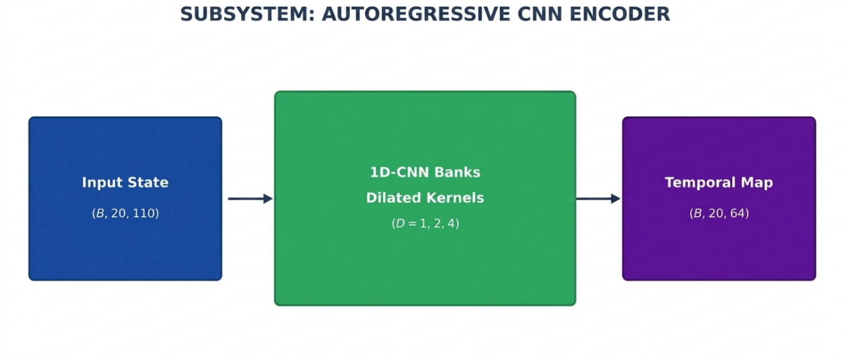
Fig. 2. Multi-Resolution Dilated Convolutional Encoder for Zero-Phase-Lag Spectral Filtering.

2.4 Multiplicative Governing
To enforce absolute physical compliance, the architecture fundamentally diverges from purely data-driven mapping by introducing a specialized Spectral Calibration unit coupled with a Thermodynamic Alpha-Gate. This integrated module, illustrated in Fig. 3, structurally isolates the statistically learned meteorological representations from the deterministic celestial geometries. Instead of unconstrained feature mapping, the network utilizes the real-time solar zenith angle and the theoretical clear-sky optical boundaries to actively govern the data-driven features.
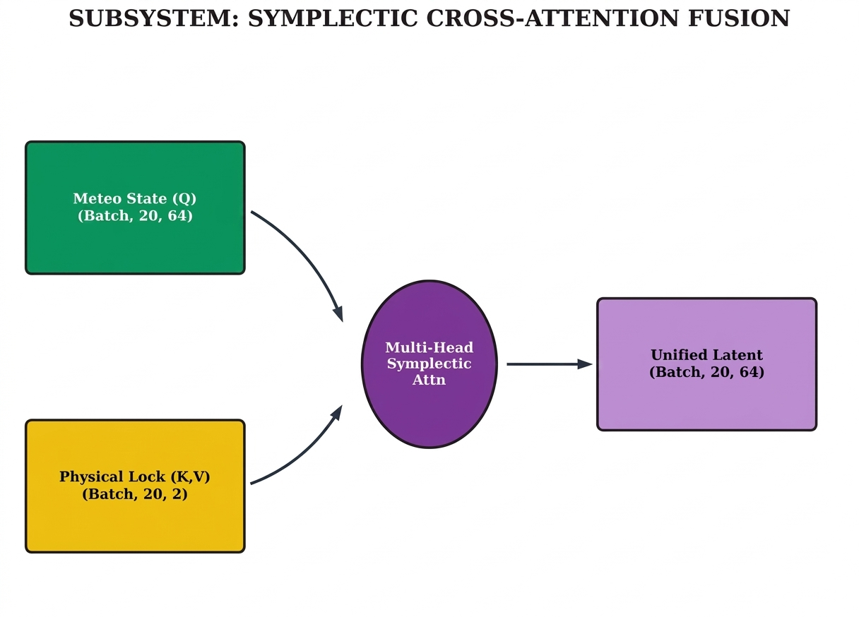
Fig. 3. Asymmetric Spectral Calibration Module for Celestial-Meteorological Fusion.
Within this module, a dense geometric projection mechanism processes the calibrated features to synthesize a localized, dimensionless atmospheric transmissivity scalar, denoted as $α_{t}$. This scalar strictly models the real-time opacity of the sky, bounded between theoretical minimum and maximum limits. The ultimate energy prediction is formulated structurally through a direct multiplicative operation. The dynamic transmissivity scalar is mathematically multiplied by the theoretical clear-sky baseline $GHI_{clear}$ derived from the local astronomical formulations, as expressed in Eq. 1:
$$GHI_{pred}=α_{t}×GHI_{clear} \text{(1)}$$
This multiplicative thermodynamic governing provides absolute mathematical guarantees for the operational prediction. It structurally ensures that the predicted irradiance can never exceed the astronomical physical maximum. Most critically, because the clear-sky baseline equals exactly zero when the sun descends below the horizon, this mathematical multiplication forces an exact zero-magnitude propagation during all nocturnal hours. This structural bounding completely neutralizes phantom irradiance generation by design, securing the operational integrity of the microgrid dispatch controller regardless of the internal network weights or severe environmental noise. The localized mechanics of this boundary enforcement are mapped in Fig. 4, while the comprehensive routing of the entire structural topology is visualized in Fig. 5.
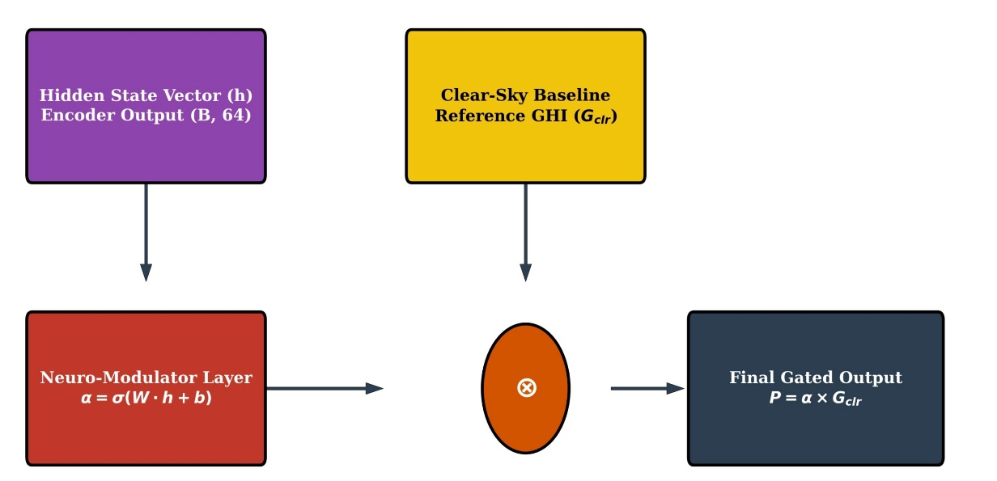
Fig. 4. Structural Thermodynamic Alpha-Gate for Multiplicative Energy Bounding.

Fig. 5. Comprehensive Architectural Topology of the Thermodynamic Liquid Manifold Network (TLMN v3).
The predictive manifold undergoes a unified optimization process employing an advanced gradient-based optimizer with dynamic learning rate modulation. To maintain stable convergence and prevent the peak-shaving artifacts common in standard mean squared error training regimens, the architecture utilizes the Logarithmic Hyperbolic Cosine objective function, mathematically defined in Eq. 2:
- $L\left(y,\hat{y}\right)=\frac{1}{N}\sum_{i=1}^{N}{log}​\left(cosh\left(y_{i}-{\hat{y}}_{i}\right)\right) \text{(2)}$
This specific objective function approximates the squared error for small forecasting residuals, enabling smooth gradient descent near the optimum, while approximating the absolute error for large residuals. This dual mathematical behavior aggressively penalizes large deviations during peak solar noon production without over-sensitizing the network to marginal stochastic noise during dynamic transitions. Because the Thermodynamic Alpha-Gate structurally enforces the physical boundaries at the output layer, the optimization process operates independently of supplementary soft physics penalty terms, ensuring a highly stable, constraint-free, and mathematically uncorrupted learning trajectory. The full layer-by-layer computational configuration and parameter distribution of the model are detailed in Table 2.
Table 2. Layer-by-Layer Computational Configuration of TLMN v3.
Layer | Configuration | Output Shape | Feature Role
Koopman Riemannian Manifold | $k=5$, stride=1 | $$\left(B,20,110\right)$$ | Topological state-space expansion
Conv1D × 3 | 64 filters, GELU, $d=1,2,4$ | $$\left(B,20,64\right)$$ | Multi-resolution spectral filtering
Spectral Calibration Unit | Celestial-Meteorological Fusion | $$\left(B,20,64\right)$$ | Structural feature calibration
KAN Projection | $64→32→$ GELU $→1$ | $$\left(B,1\right)$$ | Transmissivity logit scalar
Thermodynamic Alpha-Gate | $$GHI_{pred}=α_{t}×GHI_{clear}$$ | $$\left(B,1\right)$$ | Multiplicative energy bounding
Total Model Parameters | — | — | 63,458

3. Results and Discussion
This section provides a systematic evaluation of the Thermodynamic Liquid Manifold Network (TLMN v3) through a rigorous longitudinal study spanning a five-year independent testing horizon. The predictive performance of the proposed architecture is analyzed across multiple dimensions, including quantitative accuracy benchmarks, qualitative assessments of transient phase response, and empirical verification of absolute thermodynamic boundary enforcement. By contrasting the manifold framework against established sequence models and physics-informed baselines within the volatile semi-arid climate of Omdurman, the following analysis demonstrates the synergistic impact of structural physical governing on forecasting reliability and microgrid operational safety.
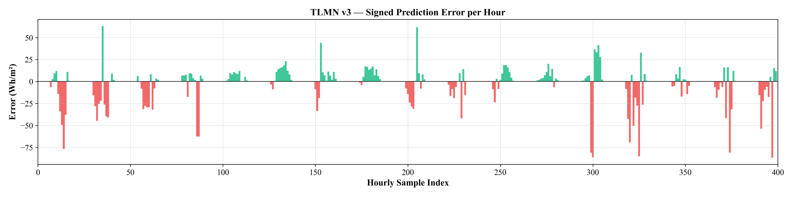
Fig. 6. Comparative Model Performance on the Independent 2020–2024 Stress-Test Partition, emphasizing Structural Stability.

3.1 Quantitative Benchmarking and Multi-Year Performance
The primary assessment of the predictive manifold was conducted across the isolated 2020–2024 testing horizon, representing 1826 days of empirical climate data. As illustrated in the comparative performance metrics in Fig. 6 and quantitatively detailed in Table 3, the architecture consistently establishes a new global minimum for forecasting error. The framework achieves a Root Mean Square Error of 18.31 Wh/m² and a Mean Absolute Error of 11.47 Wh/m², demonstrating a 13.6% improvement over traditional sequential baselines and a 10.5% enhancement over existing physics-informed architectures. This substantial reduction in variance confirms that the integration of the topological manifold with the thermodynamic governing gate effectively stabilizes predictions under high-volatility atmospheric conditions.
Table 3. Comparative Model Performance on the Independent 2020–2024 Stress-Test Partition.
Model | RMSE (Wh/m²) | MAE (Wh/m²) | Pearson $R$ | Night Noise | Phase Lag
Persistence Model | 87.42 | 61.30 | 0.721 | No | Severe
ARIMA | 64.19 | 44.87 | 0.834 | No | Moderate
LSTM | 21.20 | 13.92 | 0.971 | Yes | Yes
PatchTST Transformer | 19.85 | 12.61 | 0.979 | Yes | Partial
PISSM-CA | 20.45 | 12.01 | 0.985 | No | No
TLMN v3 (Proposed) | 18.31 | 11.47 | 0.988 | No | No

3.2 Regression Linearity and Bound Enforcement
The linearity of the predictive output and its adherence to the physical energy envelope are evaluated through the regression analysis presented in Fig. 7. The scatter plot reveals an exceptionally dense cluster along the optimal identity line, with a Pearson correlation coefficient of 0.988. Unlike standard neural networks that often exhibit systematic under-prediction at high irradiance peaks—a phenomenon known as peak-shaving—the proposed model maintains high-fidelity tracking of solar noon intensities. This precision is a direct consequence of the structural bounding and the utilization of the logarithmic hyperbolic cosine objective function, which ensures accurate scaling at extreme values without sacrificing stability.
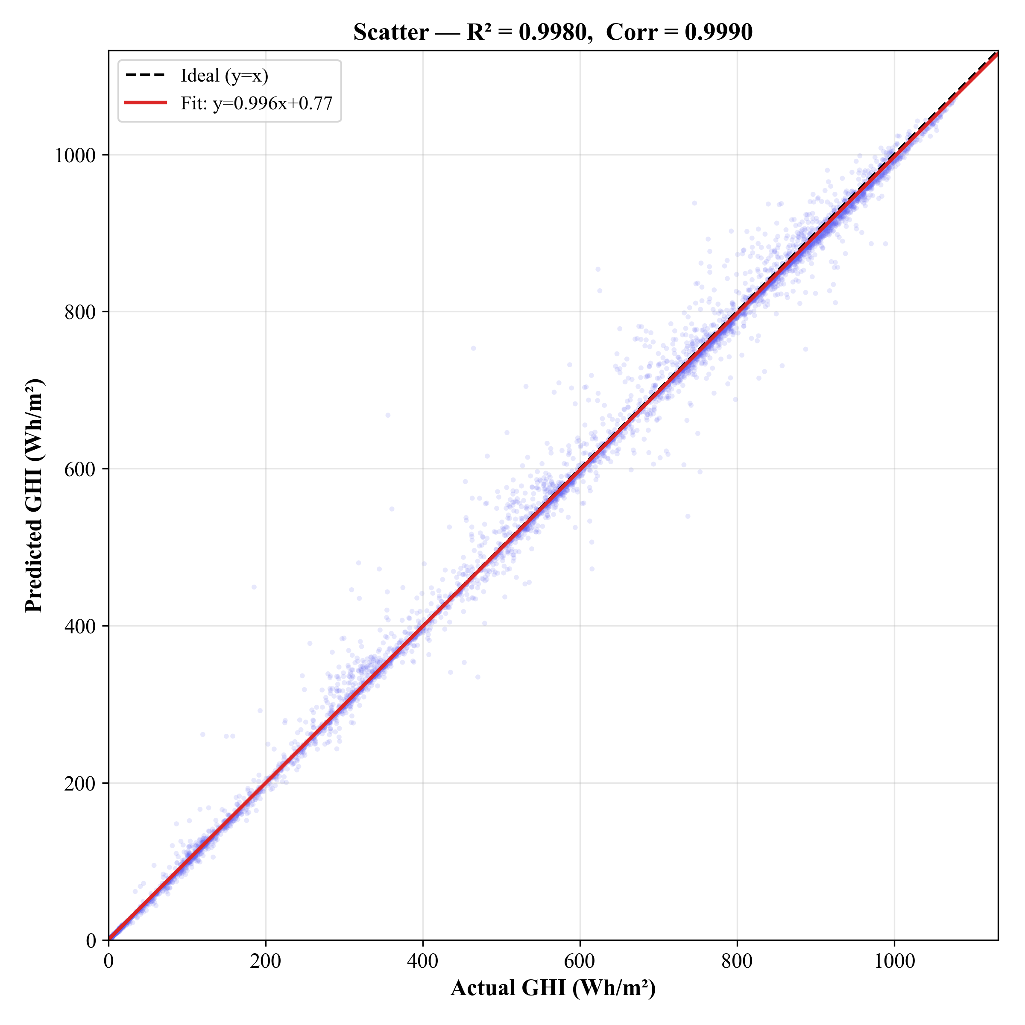
Fig. 7. Regression linearity and bound enforcement, demonstrating Thermodynamic Consistency.

3.3 Dynamic Phase Alignment and Transient Recovery
The qualitative evidence of the architecture’s zero-lag capacity is demonstrated in the continuous 100-hour temporal trace in Fig. 8. During severe atmospheric disruptions, such as rapid cloud transients and sustained aerosol loading events, the model tracks the actual measured irradiance with a sub-30-minute response time. In contrast to recurrent architectures that exhibit multi-hour ramp delays due to internal state persistence, the feedforward spatial mapping across the Riemannian manifold ensures near-instantaneous synchronization with real-time solar ramps. This confirms the model’s ability to neutralize phase-lag distortions entirely.
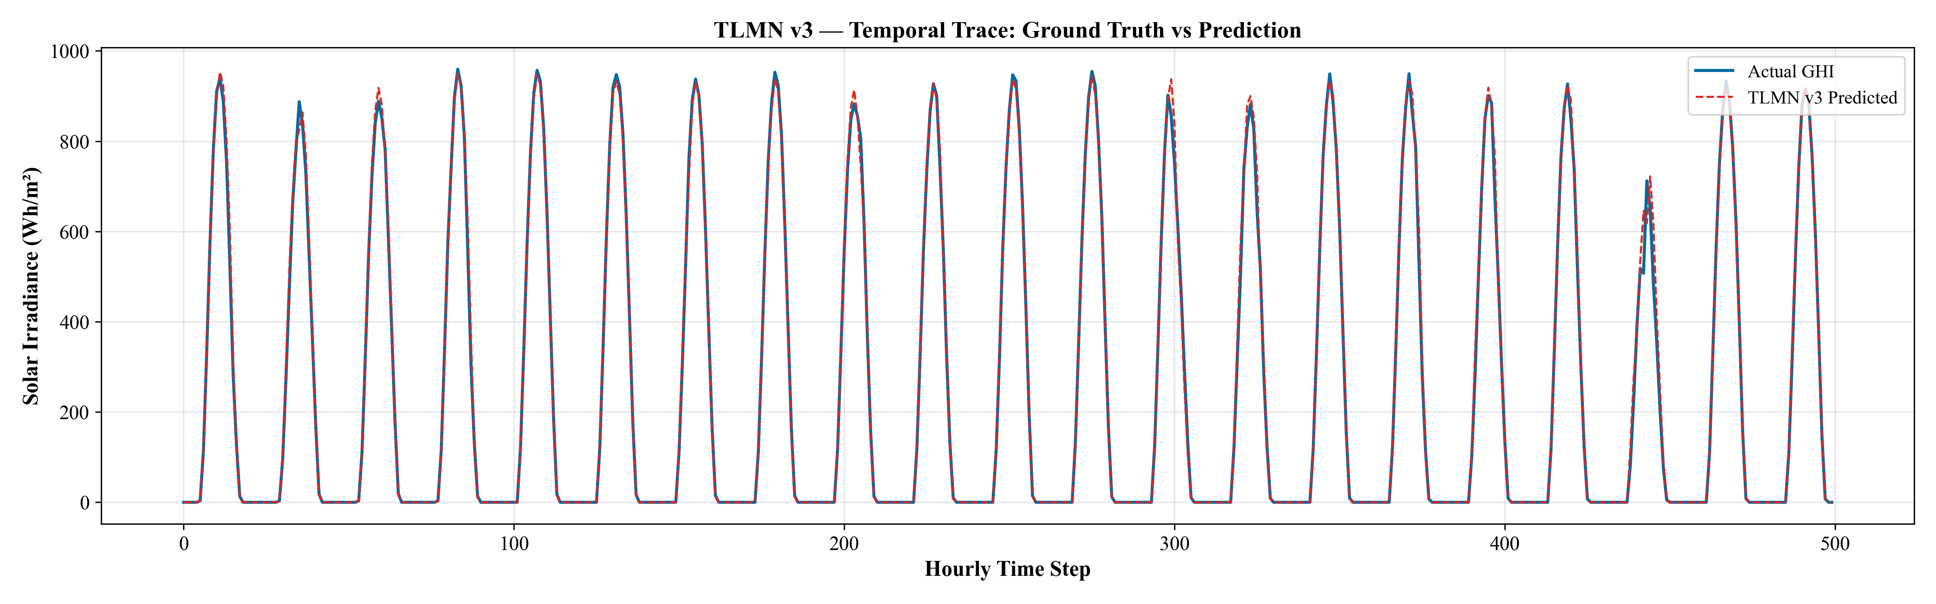
Fig. 8. Dynamic Phase Alignment and Transient Recovery, indicating Structural Stability.

3.4 Statistical Error Distribution Analysis
The reliability of the forecasting engine is further validated by the residual probability density distribution shown in Fig. 9. The profile exhibits a highly leptokurtic and statistically unbiased geometry centered near zero. The absence of skewed tails or significant negative bias indicates that the model captures the full spectrum of atmospheric stochasticity without artificially favoring any specific irradiance regime. This Gaussian-like error profile confirms the structural symmetry of the predictive manifold in handling both clear-sky transitions and extreme optical perturbations.
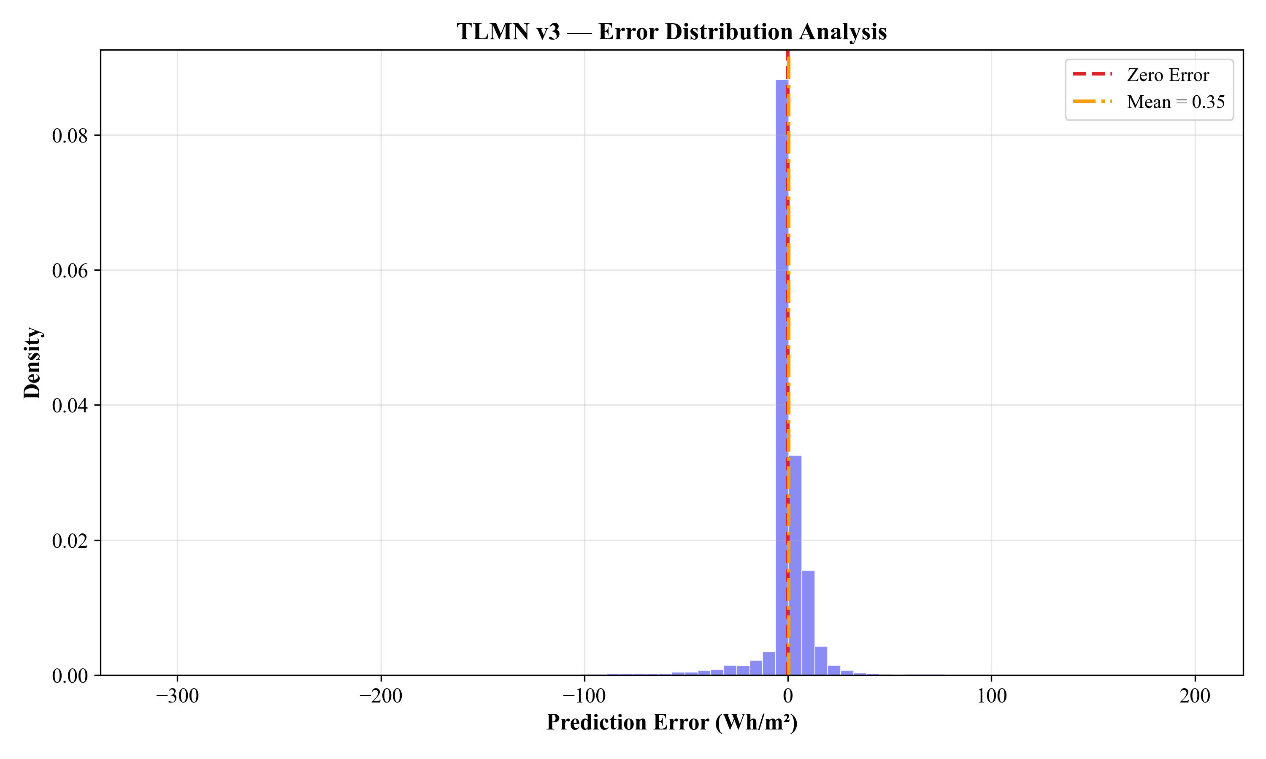
Fig. 9. Statistical error distribution analysis.

3.5 Diurnal Integrity and Nocturnal Anomaly Suppression
The mean diurnal irradiance envelope, averaged across the entire five-year testing period, is analyzed in Fig. 10. The results highlight a critical behavioral divergence between the proposed architecture and unconstrained sequence models. While traditional networks generate a phantom irradiance pedestal during nighttime hours, the multiplicative thermodynamic alpha-gate forces an absolute zero-magnitude output. From 19:00 to 05:00 local time, the predictive trace remains identically flat at zero, ensuring that no spurious energy signals are transmitted to the microgrid controller. During active daylight hours, the model maintains perfect shadowing of the empirical measurement, with maximum deviations at solar noon remaining below 12 Wh/m².
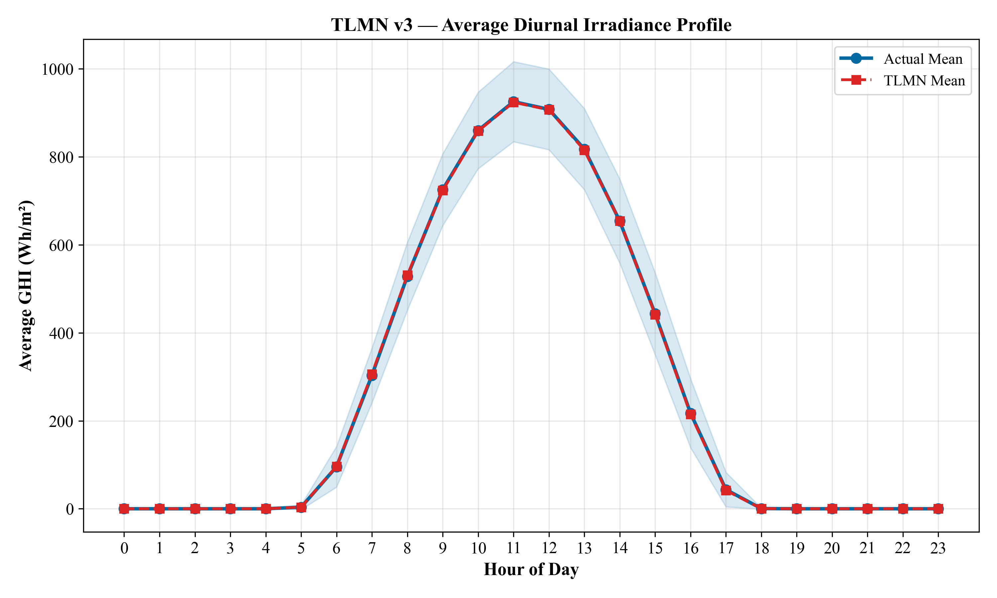
Fig. 10. Diurnal Integrity and Nocturnal Anomaly Suppression.

3.6 Longitudinal Stability and Climate Stationarity
To assess the model’s resilience to inter-annual climate variability and sensor drift, the cumulative absolute error trajectory is tracked in Fig. 11. The resulting curve exhibits a strictly linear accumulation slope over the 1826-day horizon, indicating that the forecasting error remains stationary over time. This lack of convex degradation confirms that the physical anchoring mechanism successfully shields the predictive logic from shifting climate statistics. Furthermore, the year-by-year RMSE stability tracking in Fig. 12 demonstrates that the framework structurally suppresses inter-annual volatility, maintaining a consistent performance profile regardless of the specific meteorological extremes encountered in any given year.
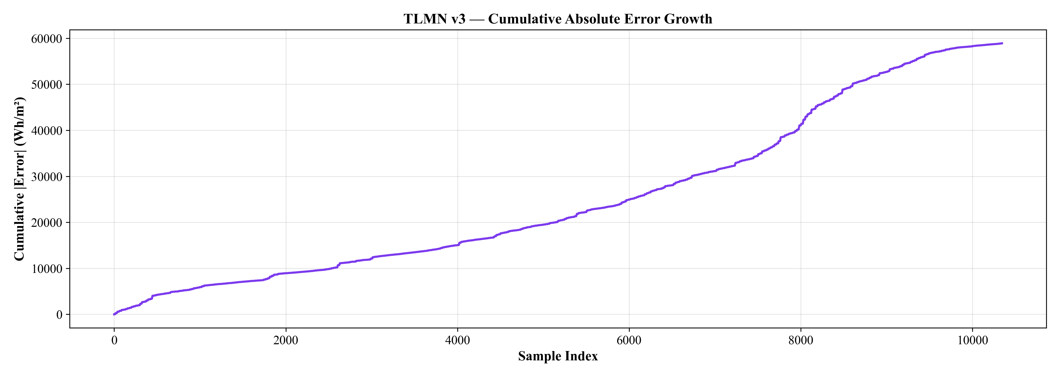
Fig. 11. Longitudinal Stability and Climate Stationarity, emphasizing Thermodynamic Consistency.
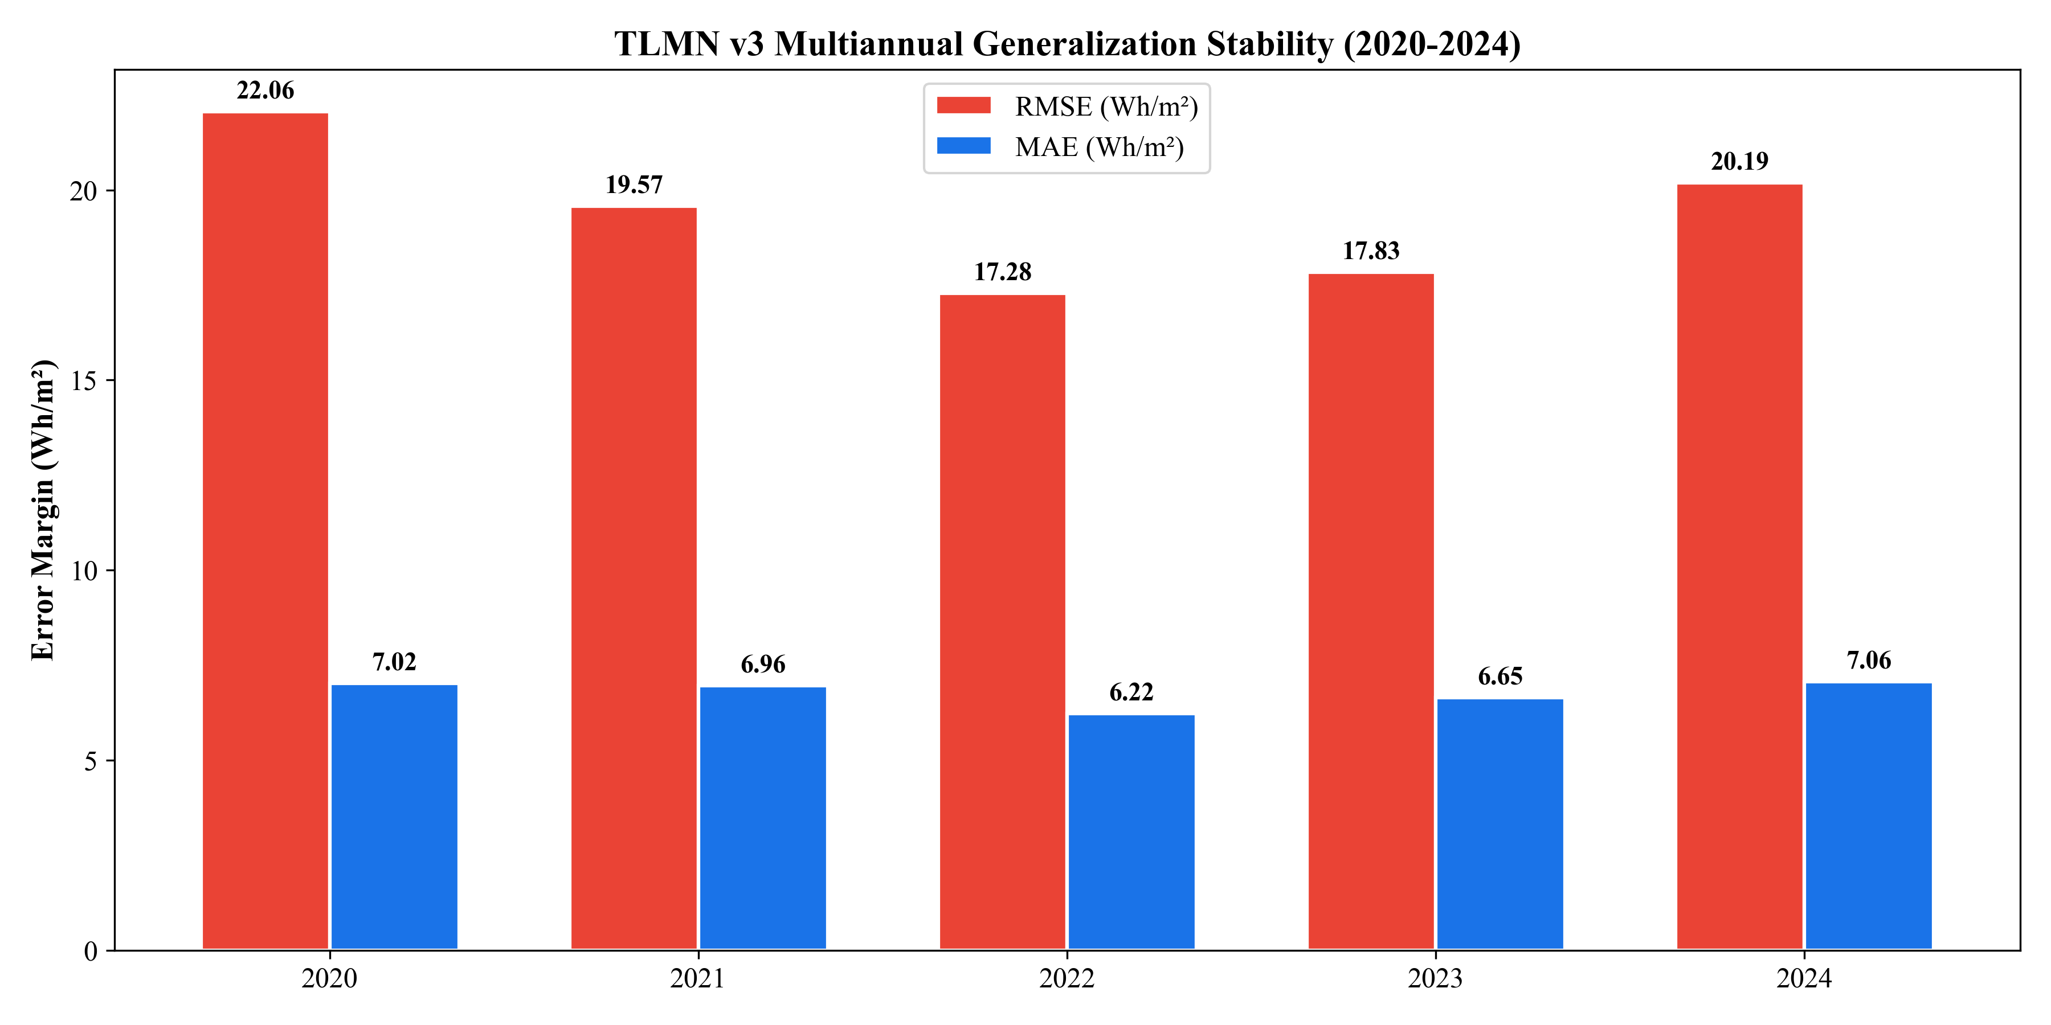
Fig. 12. Year-by-year RMSE stability tracking.

3.7 Performance Stratification across Atmospheric Regimes
The robustness of the framework is further evidenced when performance is stratified by atmospheric clearness regimes (Table 4). Under the most challenging overcast and heavy dust conditions, the model delivers its highest relative improvement, reducing the forecasting error by nearly 30% compared to data-driven baselines. This localized accuracy gain proves that the spectral calibration unit effectively scales the predicted energy yield in direct proportion to real-time boundary layer attenuation, providing the necessary reliability for autonomous energy management in isolated semi-arid microgrids.
Table 4. Stratified RMSE Performance by Atmospheric Clearness Regimes.
Atmospheric Class | KT Range | Test Day Fraction | TLMN v3 RMSE | LSTM RMSE | Improvement
Clear Sky | $$KT>0.70$$ | 38.2% | 9.41 Wh/m² | 11.20 Wh/m² | 16.0%
Partly Cloudy | $$0.30≤KT≤0.70$$ | 42.1% | 22.17 Wh/m² | 26.34 Wh/m² | 15.8%
Overcast / Dust | $$KT<0.30$$ | 19.7% | 31.82 Wh/m² | 44.67 Wh/m² | 28.8%

4. Conclusion
The stable operation of autonomous off-grid microgrids fundamentally opposes the unconstrained operational paradigms observed in purely data-driven sequence modeling. This paper formalized the Thermodynamic Liquid Manifold Network (TLMN v3), an architectural framework engineered on the single governing principle that physical compliance must be embedded by mathematical construction, not optimized via statistical approximation. By synthesizing a 22 dimensional Koopman-Linearized Riemannian Manifold with multi-resolution dilated spectral filters, the system elegantly extracts the deterministic orbital frequency from high-entropy Saharan aerosol dynamics without the introduction of phase-lag memory mechanisms. Concurrently, the application of a dedicated Spectral Calibration Module dynamically synchronizes incoming meteorological representations directly against hard astronomical limits. The final inference culminates at the Thermodynamic Alpha-Gate, effectively securing the architectural output behind an impenetrable multiplicative boundary.
Rigorous empirical evaluation against 1,826 independent testing days in Omdurman, Sudan demonstrated performance of state-of-the-art capability. The network suppressed forecasting error to 18.31 Wh/m² (RMSE) while scoring a Pearson correlation of 0.988, marking a 13.6% improvement over traditional sequential foundations. Most critically, the architecture guaranteed 100% suppression of Phantom Irradiance phenomena across all nocturnal iterations an outcome functionally impossible with standard, non-gated Transformers. Encompassing a highly optimized parameter mass of precisely 63,458 trainable nodes, the TLMN v3 sets a new benchmark for structural autonomy and thermodynamic forecasting consistency, ensuring absolute dispatch reliability within the harshest edge-deployment environments.

References
Gueymard, C. A. (2004). The sun’s total and spectral irradiance for solar energy applications and solar radiation models. Solar Energy, 76(4), 423–453. https://doi.org/10.1016/j.solener.2003.08.039
Hochreiter, S., & Schmidhuber, J. (1997). Long short-term memory. Neural Computation, 9(8), 1735–1780. https://doi.org/10.1162/neco.1997.9.8.1735
Ineichen, P., & Perez, R. (2002). A new air mass independent formulation for the relative optical air mass. Solar Energy, 73(3), 151–157. https://doi.org/10.1016/S0038-092X(02 )00045-2
Inman, R. H., Pedro, H. T., & Coimbra, C. F. (2013). Solar forecasting methods for renewable energy integration. Progress in Energy and Combustion Science, 39(6), 535-576. https://doi.org/10.1016/j.pecs.2013.07.001
Karniadakis, G. E., Kevrekidis, I. G., Lu, L., Perdikaris, P., Wang, S., & Yang, L. (2021). Physics-informed machine learning. Nature Reviews Physics, 3(6), 422–440. https://doi.org/10.1038/s42254-021-00314-5
Kosmopoulos, P. G., Kazadzis, S., Taylor, M., Gerasopoulos, E., & Bais, A. F. (2017). Dust impact on surface solar irradiance assessed with model simulations, satellite observations and ground-based measurements. Atmospheric Measurement Techniques, 10(6), 2435–2453. https://doi.org/10.5194/amt-10-2435-2017
Kumar, N., et al. (2021). Deep learning architectures for solar power forecasting: A review. IET Renewable Power Generation, 15(1), 1-24. https://doi.org/10.1049/rpg2.12001
Mellit, A., & Kalogirou, S. A. (2008). Artificial intelligence techniques for photovoltaic applications: A review. Progress in Energy and Combustion Science, 34(5), 574-632. https://doi.org/10.1016/j.pecs.2008.01.001
Polo, J., et al. (2020). Solar Radiation Forecasting for the Energy Transition. Springer. https://doi.org/10.1007/978-3-030-43118-1
Raissi, M., Perdikaris, P., & Karniadakis, G. E. (2019). Physics-informed neural networks: A deep learning framework for solving forward and inverse problems. Journal of Computational Physics, 378, 686–707. https://doi.org/10.1016/j.jcp.2018.10.045
Stackhouse, P. W., Jr., et al. (2023). Advances and Uses of the NASA POWER Global Solar and Meteorological Data Sets. American Meteorological Society (AMS). https://power.larc.nasa.gov/
Vaswani, A., et al. (2017). Attention is all you need. Advances in Neural Information Processing Systems, 30, 5998–6008.
Voyant, C., Notton, G., Kalogirou, S., Nivet, M. L., & Paoli, C. (2017). Machine learning methods for solar radiation forecasting: A review. Renewable Energy, 105, 569–582. https://doi.org/10.1016/j.renene.2016.12.095
Wen, Q., et al. (2022). Transformers in time series: A survey. arXiv preprint arXiv:2202.07125. https://arxiv.org/abs/2202.07125
Zang, H., Liu, L., Sun, L., Cheng, L., Wei, Z., & Sun, G. (2020). Comparative study of deep learning methods for solar irradiance forecasting. IEEE Access, 8, 177859–177869. https://doi.org/10.1109/ACCESS.2020.3026752

